Contents

Accessing the system 1

Navigating to the Reviewer Dashboard 2

Viewing applications 3

Recording Reviews 5

Offline Reviewing and Score Sheets 6

# Accessing the system

1. Once you are ready to carry out your scoring actions, navigate to the Alan Turing Institute system available at <https://ati.flexigrant.com/>. This will allow you to login by selecting the ‘Login’ icon at the top-right hand of the page.

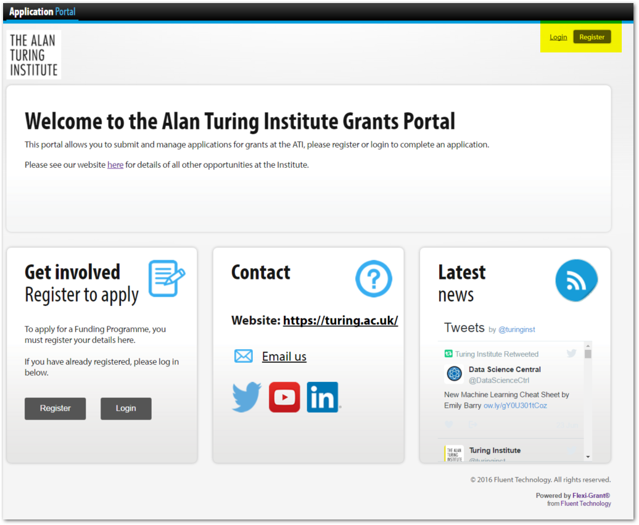  
  
Your email address will be the email address the Turing used to send you these instructions. You can then select the ‘Forgot password?’ option to reset your password if required. You may have also received an activation email which you can use to gain access to the system.  
  
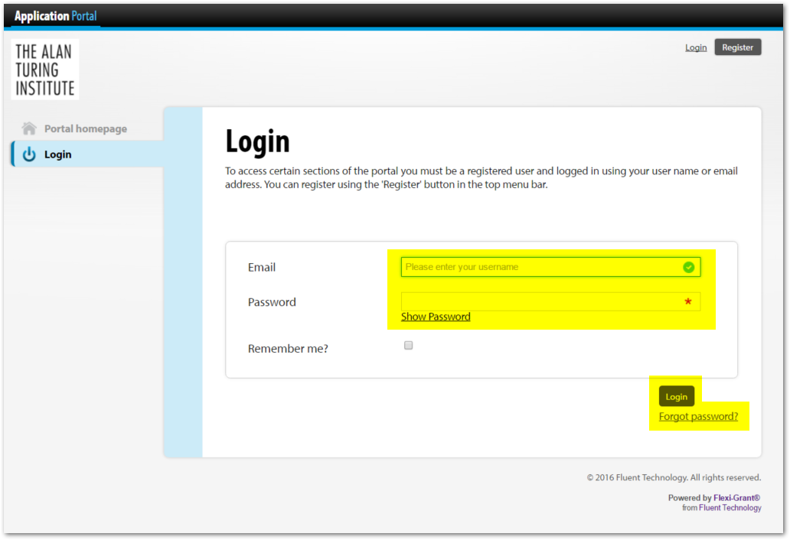

# Navigating to the Reviewer Dashboard

1. Please click on the ‘My Assessments’ option (at the top of the page).

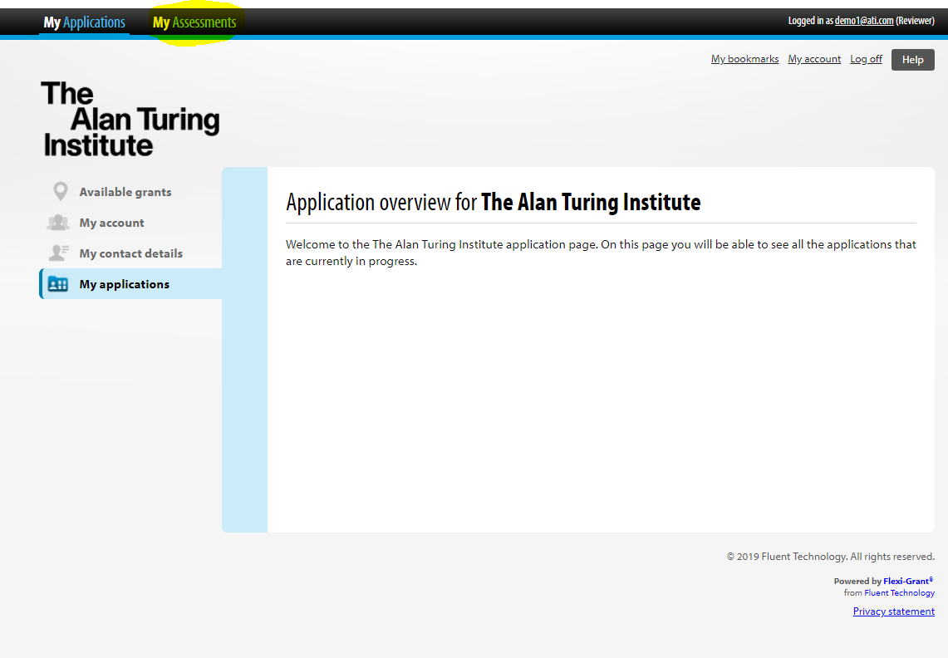

1. Once you access the system you will see your reviewer dashboard. From here you can access all the applications that have been assigned to you. The reviewer dashboard shows you an overview of all the applications you have been assigned to review.

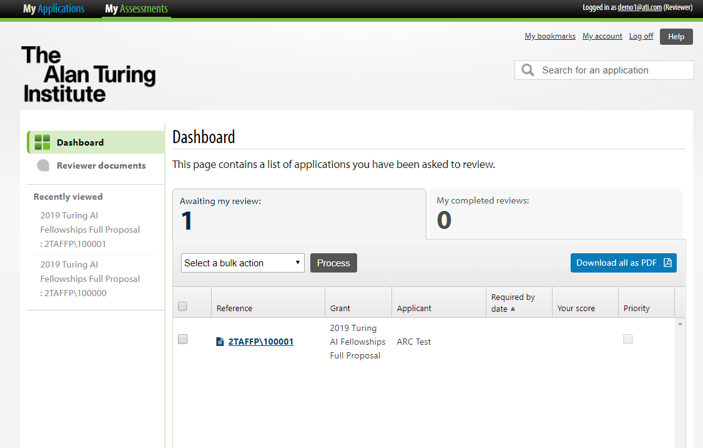

# Viewing applications

1. To view an application (including score sheet) select the application reference number.

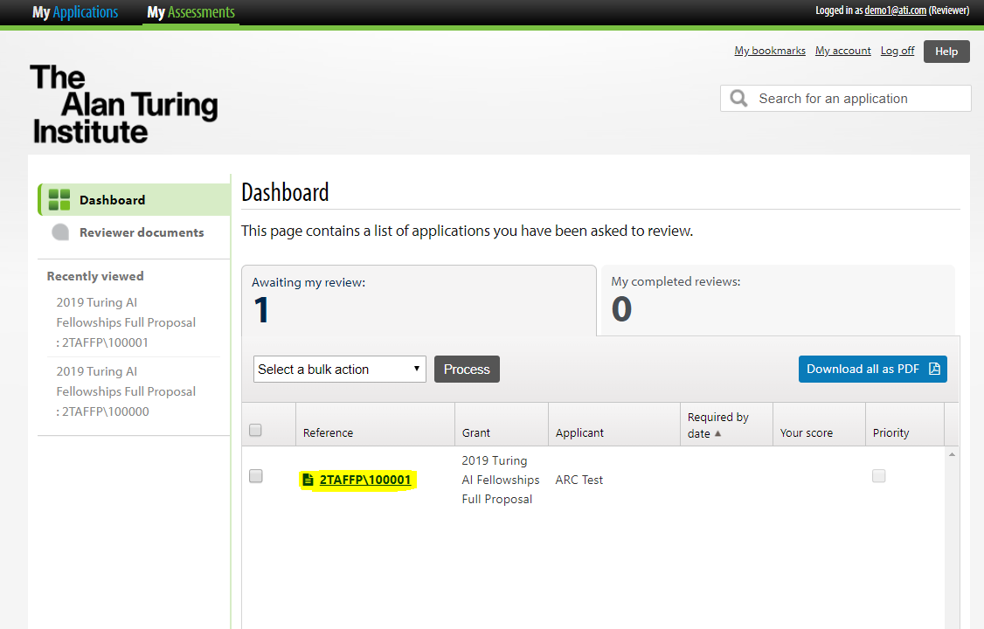

1. This will open a review window. From here you may select one of the following options:
   1. Review Form tab – Once you have completed the conflict of interest declaration this tab will show the review form for completion.
   2. Related documents – This tab lists all documents related to the application.
   3. Open application form – This button will open a PDF version of the application form (with linked to uploaded documents) in a new window.

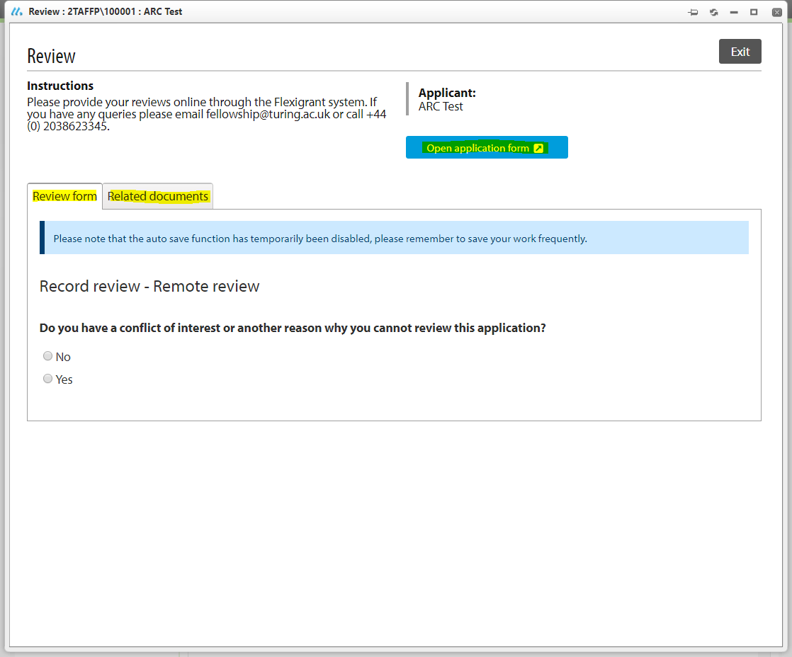

1. If you would like to review multiple applications, please select applications through the check box list to the left. Then choose ‘Record reviews’ from the drop down menu and select ‘Process’. Similarly, you may choose to ‘Download all as PDF’ on the right hand side.

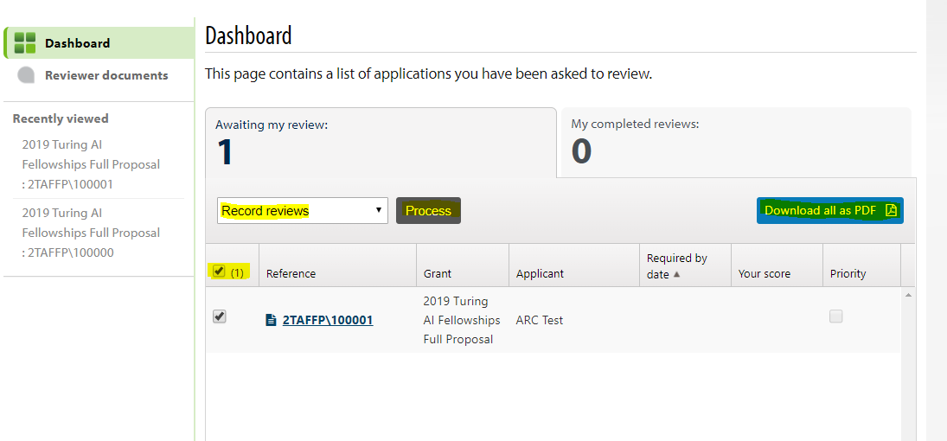

1. Once you have chosen your multiple Applications, these can be cycled through by selecting the ‘Previous’ and ‘Next’ buttons available at the top of the page or choosing a specific Application from the selectable dropdown list.  
     
   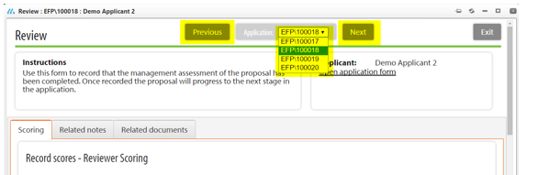

# Recording Reviews

1. Navigate to the review window as above and complete the conflict of interest declaration. Selecting ‘No’ will display the review form. To carry out your scoring complete the review form for each candidate by entering a score and a mark for each of the six criterion and an overall score and remark.

You will also be asked to indicate and remark on your overall confidence level.   
  
  
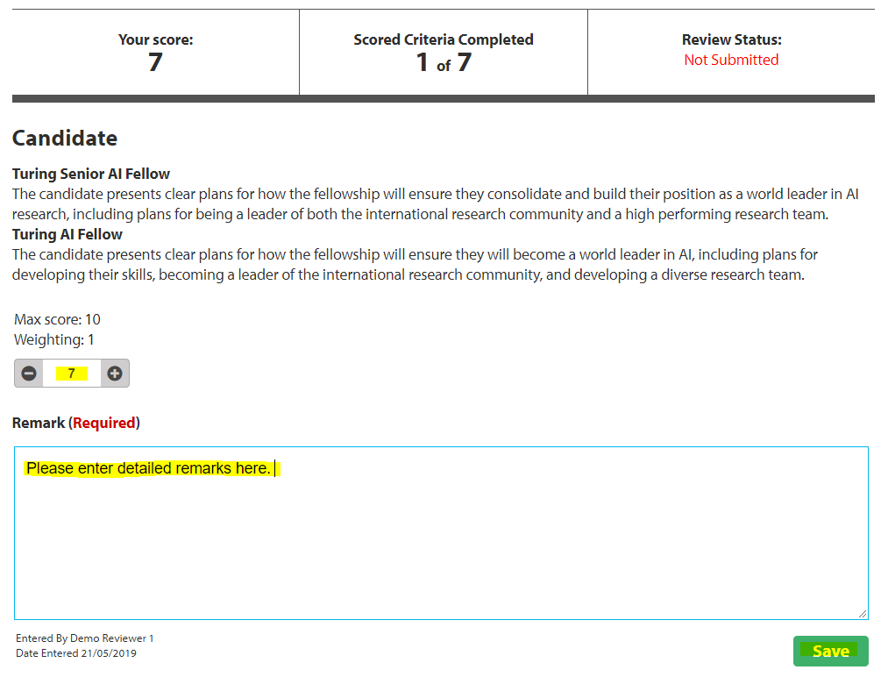  
  
  
**Please note:** The review form contains ‘remarks’ sections. These *are* required to be completed and are for the final panel to use when making offers. Please ensure you leave a detailed comment for each criterion to explain your score and inform the interview panel. *Reviews will be shared anonymously with candidate.*

1. Select the ‘Save’ button available at the bottom of the scoring page to save your scores. This will save your work to the system and allow you to return and complete it at a later date. When you are happy to submit your scoring to the system, click to select the ‘Submit’ button. This will move the application to ‘My completed reviews’. You will however be able to change and resubmit your scores up until the deadline for submission.   
     
   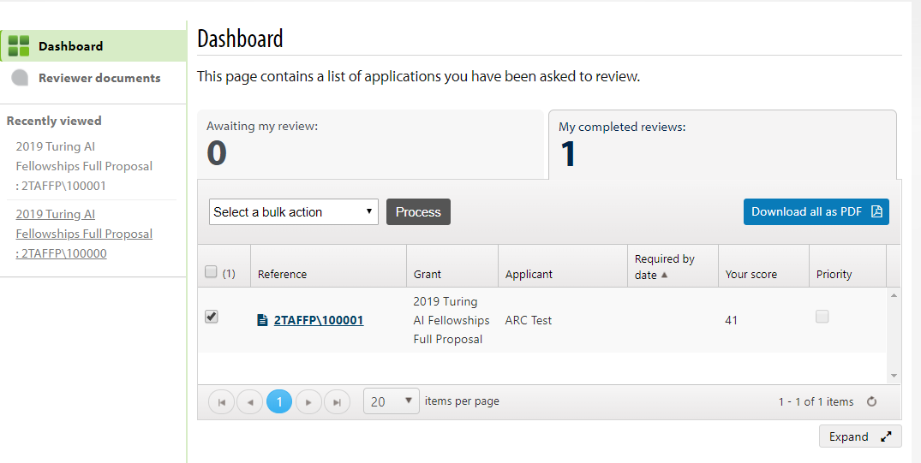

# Offline Reviewing and Score Sheets

If you need to conduct your scoring outside of the system before returning to submit your reviews, you can **a)** Download a PDF copy of the application form for printing, **b)** Download a MS Word copy of the review form.

1. **Downloading a PDF copy of the application**

To download a copy of the Application in PDF format, click to select the reference number for the Application you wish to generate the document for. You can then select to download a PDF version from either the drop down menu or button to the right. 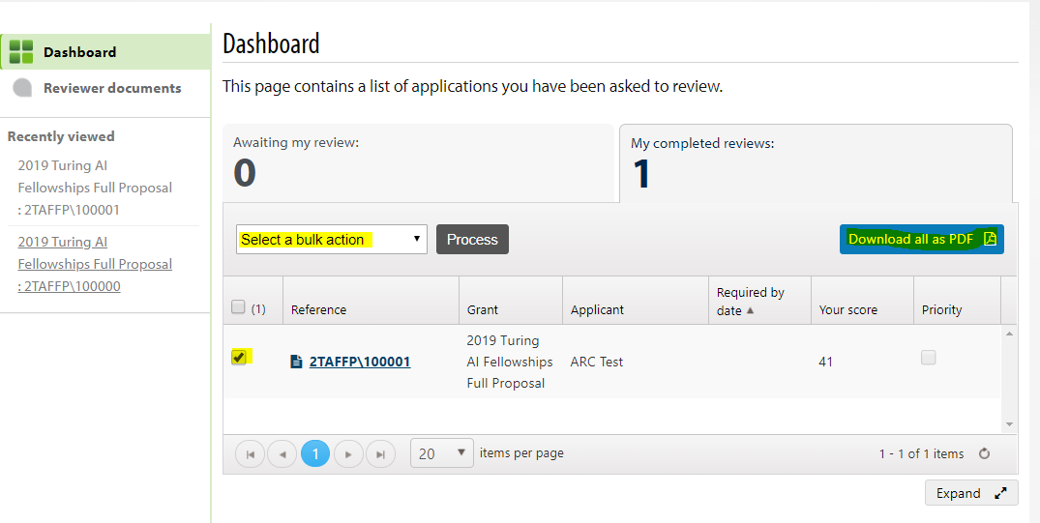

**b)** **Downloading a blank review form**

To download a blank review form in MS Word Format, please navigate to the Review Form window in Flexigrant. Scroll to the bottom of the form where you will see the option to ‘Download blank review form’. Select this button to download the form.

Please note that you are still requested to enter your reviews into the Flexigrant system. If you have any trouble with these please contact [fellowship@turing.ac.uk](mailto:fellowship@turing.ac.uk).

